System Security: Lab Manual

MS Cyber Security

ITU Lahore



Submitted to: Muhammad Shehryar Raza

Submitted By: Arshiya khan

Roll No: MSCS24009

Lab 8: System Call Sandboxing with Seccomp / Firejail
Duration: 2 Hours
Tools:
- Linux (Ubuntu/Kali)
- seccomp-tools or firejail
- strace

1. Learning Objectives
Students will:
- Understand Linux system calls as an attack surface
- Create a system call whitelist
- Enforce least privilege at OS level
- Observe how sandboxing blocks exploitation

2. Scenario Description
A system utility (curl) is frequently used by automated scripts.
If compromised, it could be abused to:
- Spawn shells
- Read sensitive files
- Execute arbitrary binaries
Your task is to sandbox the utility so it can perform its legitimate function but nothing else.

3. Group Roles
- Sandbox Engineer (MSCS22007): Creates the seccomp profile
- Attacker (MSCS24003): Attempts to abuse the program
- Observer (MSCS24009): Records allowed/blocked behavior
Roles rotate after 1 hour.

4. Environment Setup (15 minutes)
Install tools:
sudo apt update
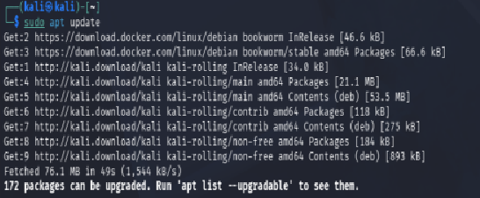
sudo apt install firejail strace -y
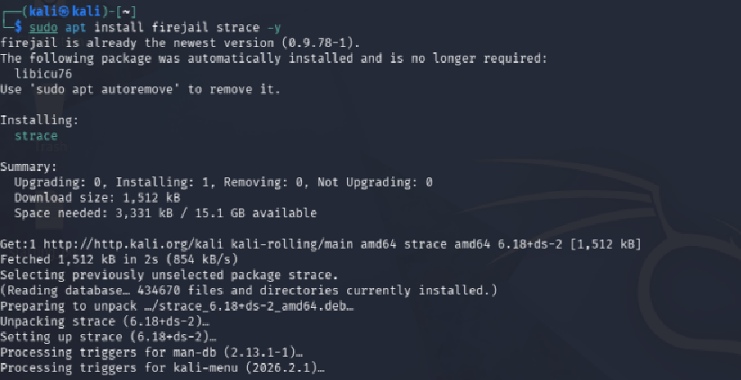
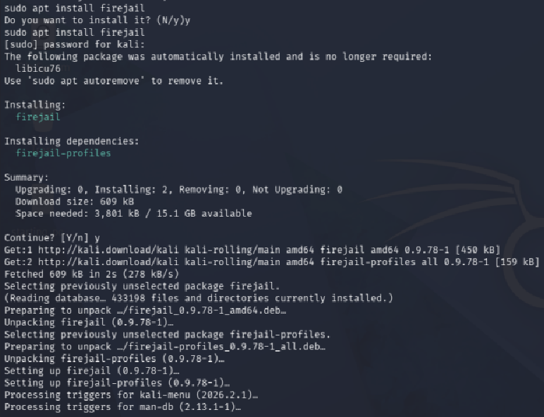
Verify:
which curl
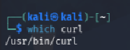

5. Step-by-Step Tasks

Task 1: Observe System Calls (20 minutes)
Run:
strace curl http://example.com
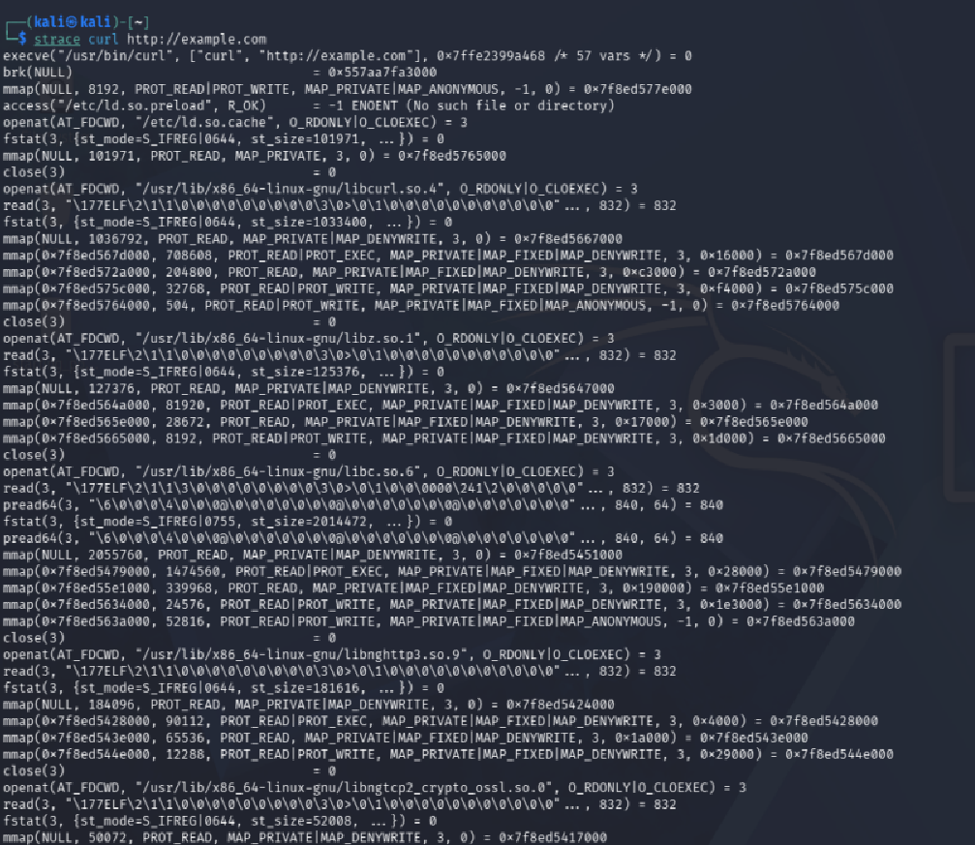
Identify:
- Network-related syscalls (connect, recvfrom)
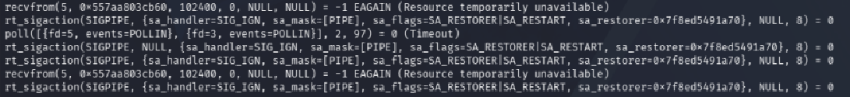
- File operations (open, read)

- Process-related calls
Write
Write
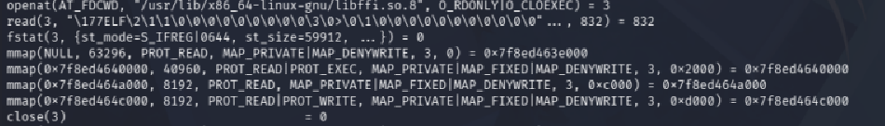
Mprotect, brk, nmap
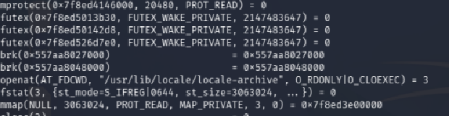
execve
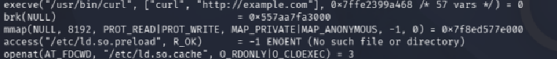
Checkpoint: List at least 5 syscalls curl uses.
- Openat
- Read
- Nmap
- Connect
- write

Task 2: Sandbox with Firejail (20 minutes)
Run curl in sandbox:
firejail curl http://example.com

Attempt forbidden actions:
firejail curl file:///etc/shadow
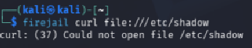
Observe:
- Permission denial

Task 3: Create Custom Seccomp Profile (25 minutes)
Create curl.profile:
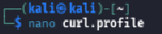
blacklist
execve
openat
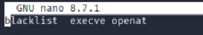
Run:
firejail --seccomp=./curl.profile curl http://example.com
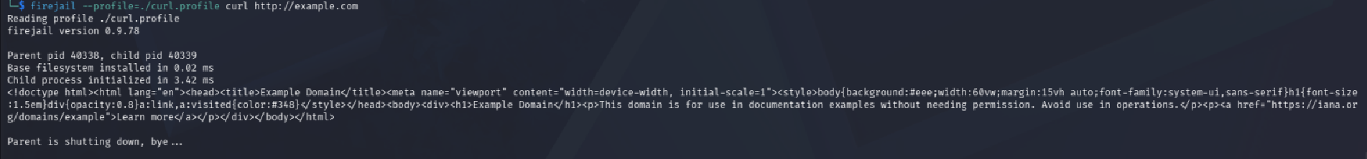
Test:
firejail --seccomp=curl.profile curl file:///etc/passwd

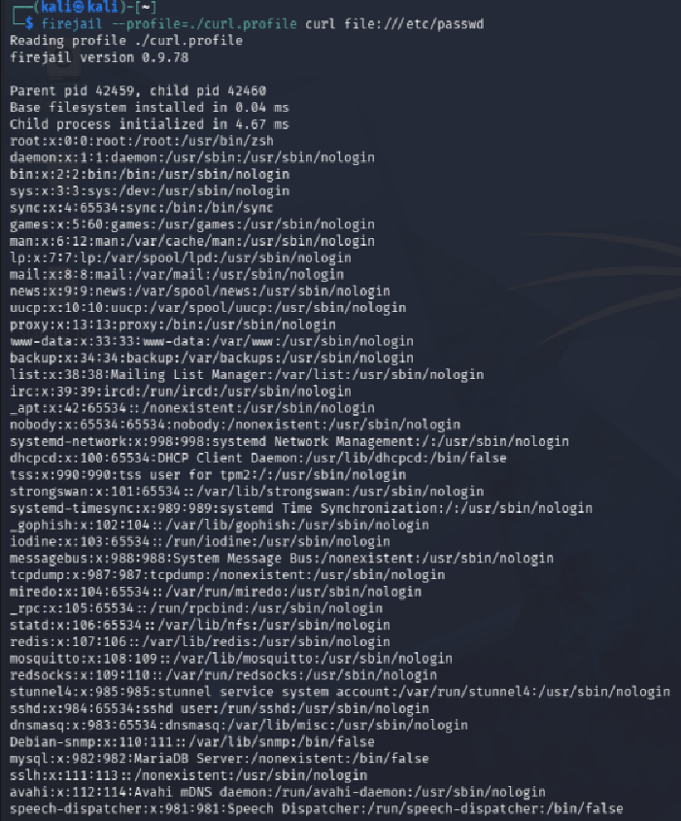
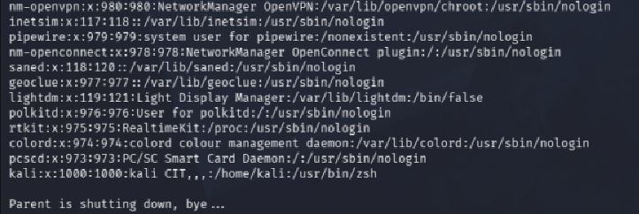

Task 4: Abuse Attempt (15 minutes)
Try:
firejail curl http://example.com; /bin/bash
Confirm shell cannot be executed.
- curl successfully fetched the page (legitimate behavior preserved)
- The attempt to chain /bin/bash did not result in an interactive shell within the sandboxed process
- This demonstrates the principle of least privilege; the sandboxed process can only do what it's supposed to do

Task 5: Reflection (15 minutes)
Answer:
- Why syscall filtering is powerful
Because every program, no matter what it does, has to go through system calls to interact with the OS. So, if we control which syscalls are allowed, we basically control what the program can and can't do at the lowest level. Even if an attacker manages to inject malicious code, if the syscall it needs (like execve to spawn a shell) is blocked, the attack just fails. It's like cutting off the hands; the brain might want to do something but it physically can't.
- Why application logic alone is insufficient

Apps can be exploited, have bugs, or behave unexpectedly under certain inputs. we can't always trust the app to police itself. For example, curl is supposed to just fetch URLs; but if there's a vulnerability in it, an attacker could make it do much more. Relying only on the app to “behave” is like trusting someone not to steal just because they said they wouldn't. You need enforcement at a deeper level, not just good intentions in the code.
- Where sandboxing is used in real systems (browsers, containers)
It's actually everywhere once we start looking. Browsers like Chrome run each tab in its own sandboxed process so if one tab gets compromised, it can't touch the rest of the system. Docker containers use Linux namespaces and seccomp profiles to isolate applications. Android apps are sandboxed so they can't access each other's data. Even PDF readers and media players sometimes run in restricted environments now because they're common attack targets.

